GOG.com Business Analytics Project

Executive Summary

I have been hired to analyze the business strategy of GOG.com (Good Old Games), a digital storefront run by CD Projekt. GOG.com stands out because it sells games that are 100% DRM-free (Digital Rights Management-free), giving customers true ownership. My analysis focuses on GOG's unique product mix of classic titles and modern releases.
The main challenge for GOG.com is figuring out how to make the most revenue in a market dominated by huge competitors like Steam. This involves running sales but making sure those discounts boost profit instead of just making their special, DRM-free games seem cheap.

Project Goal

The goal of this project is to review the company’s product strategy. I will evaluate three major strategic areas of the GOG.com business using the data I have (Laputsky, 2025):
- Product Health and True Value: Assessing the quality and makeup of the inventory by analyzing developer performance, genre success, game age, and product types (like DLC/Bundles) to understand their true value.
- Pricing Structure Review: Evaluating the financial strategy by analyzing regional pricing, promotional efficiency, and price setting between different age groups of games (new versus back catalog) to make sure pricing is set up for success.
- Day-to-Day Strategy and Audience: Reviewing key support structures like platform compatibility, age restrictions, and developer support visibility to see how they affect user ratings and the overall customer experience.
Final Goal: To give clear, useful advice across GOG.com’s entire product strategy—from defining high-value content to setting decent prices—so that I can help make the DRM-free catalog financially strong and efficient for the long run.

Data Preparation

To achieve the set goal, the data on GOG.com (Laputsky, 2025) has been structured into 6 core entity tables, 3 information or status tables and 2 junction tables. The SQL code used to create the tables can be found on my Github page (Melvinquashie, progect_query.sql).

- Core Entity Tables
These tables hold the primary, non-repeating data elements.
Table Name | Primary Key (PK) | Attributes/Columns | Foreign Key (FK) | Source Columns
Inventory | title_id(PK) | title, slug, release_date, age_limit, is_game, is_movie, buyable, support_url | publisher_id (FK to PARTY), developer_id(FK to PARTY), type_id(FK to PRODUCT_TYPE) | id, title, globalReleaseDate, ageLimit, isGame, isMovie, buyable, supportUrl, publisher, developer, type
PARTY | party_id(PK) | name |  | developer, publisher (Unique names extracted)
PRODUCT_TYPE | type_id(PK) | type_name |  | type (1, 2, 3 mapped to 'Game', 'Bundle', 'DLC')
OS_PLATFORM | os_id(PK) | os_name |  | Unique list of OS from supportedOperatingSystems
GENRE | genre_id(PK) | genre_name |  | Unique list of genres from genres
PROMOTION | promo_id(PK) | promo_name |  | promoId (The unique campaign names)

Origin of Primary Key Values:
Primary Key | How the Value is Generated
party_id (in the PARTY table) | Generated. You extract all unique developer and publisher names from the dataset and assign a new, unique, sequential integer ID to each one (e.g., 1, 2, 3, 4...).
title_id (in the TITLEtable) | Directly mapped. This value comes directly from the original id column in the GOG dataset, which is already a unique identifier for each item.
type_id (in the PRODUCT_TYPEtable) | Directly mapped. This comes directly from the type column (1, 2, or 3) and is mapped to the descriptive name (Game, Bundle, DLC).
genre_id & os_id | Generated. You extract all unique genre names and OS names and assign a unique sequential integer ID to each name.

2. Information/Status Tables
These tables contain metrics and status flags that are specific to the title.
Table Name | Primary Key (PK) | Attributes/Columns | Foreign Key (FK) | Source Columns
RATING | title_id (PK, FK) | overall_avg_rating, filtered_avg_rating, reviews_count, is_reviewable | title_id (FK to TITLE) | overallAvgRating, filteredAvgRating, reviewsCount, isReviewable
PRICING | title_id (PK, FK) | base_amount, final_amount, amount, currency, is_free | title_id (FK to TITLE) | baseAmount, finalAmount, amount, currency, isFree
DISCOUNT_STATUS | title_id (PK, FK), promo_id(PK, FK) | discount_percentage, is_discounted | title_id (FK to TITLE), promo_id(FK to PROMOTION) | discountPercentage, isDiscounted_main, promoId

3. Junction Tables (Many-to-Many Relationships)
These tables connect records where one game can have multiple genres or support multiple operating systems.
Table Name | Composite Primary Key (PK) | Foreign Keys (FK) | Relationship
TITLE_GENRE | title_id (PK), genre_id (PK) | title_id (FK to TITLE), genre_id (FK to GENRE) | A Title can have multiple Genres, and a Genre belongs to multiple Titles.
TITLE_OS | title_id (PK), os_id (PK) | title_id (FK to TITLE), os_id(FK to OS_PLATFORM) | A Title can support multiple OS, and an OS is supported by multiple Titles.

Entity Relationship Diagram

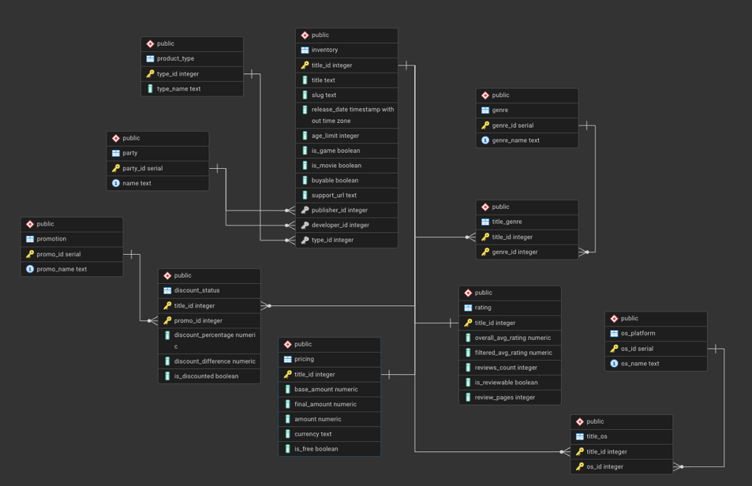
The relationships between the tables motioned above are illustrated in the below figure:
Business Questions and Answers

The SQL code used to carry out the analysis can be found on my Github page (Melvinquashie, progect_query.sql).

Product Health and True Value
This pillar focuses on assessing the intrinsic quality and makeup of GOG's game library.
- Developer/Publisher Analysis: Which Developers and Publishers are the most successful, based on median user ratings and catalog presence?
Below are the top 5 most successful Developers and Publishers on GOG.com (Melvinquashie, progect_query.sql)..
 | developer_name | catalog_presence | median_rating | publisher_name | catalog_presence | median_rating
1 | Two Point Studios | 12 | 5 | Neognosis | 7 | 5
2 | Debonosu Works | 12 | 5 | Maschinen-Mensch | 6 | 5
3 | Neognosis | 7 | 5 | Top Meadow | 5 | 5
4 | Jutsu Games | 6 | 5 | Cliax Games | 5 | 5
5 | Maschinen-Mensch | 6 | 5 | Retroware | 8 | 4.8

- Catalog Health & Age Value: How does the quality (average rating) of Classic Games compare to modern releases, and what is the dollar value of preserving those older titles?
We will define "Classic" games as those released before January 1, 2010 (Melvinquashie, progect_query.sql). This creates a clear division between the legacy PC gaming era (GOG's origin) and the modern digital distribution era.
game_era | titles_in_group | avg_quality_rating | avg_base_price
Classic (Pre-2010) | 1264 | 3.993670886 | 7.547863924
Modern (2010+) | 9632 | 3.133897425 | 16.01504257
The classic games library has a higher average quality rating. This validates GOG’s reputation for preserving high-quality beloved titles. On the other hand, the average base price of the classic games is less than half of that of the modern games. This information suggests that the classic games’ price point is losing value over time.
- Content Maturity and Audience Engagement: How does the required Age Limit for a title relate to its genre and overall review count (a measure of engagement)?
Below is how Age Limit relates to Genre (Melvinquashie, progect_query.sql):

 | genre_name | title_count | avg_age_limit |  | genre_name | title_count | avg_age_limit
1 | visual novel | 399 | 17.75689223 | 24 | turn-based | 160 | 12.78125
2 | narrative | 248 | 17.59274194 | 25 | historical | 174 | 12.67816092
3 | jrpg | 162 | 17.51851852 | 26 | comedy | 75 | 12.41333333
4 | horror | 197 | 16.74111675 | 27 | point-and-click | 144 | 12.22916667
5 | open world | 42 | 16.16666667 | 28 | sports | 14 | 12.21428571
6 | stealth | 56 | 15.78571429 | 29 | metroidvania | 21 | 12.04761905
7 | survival | 75 | 15.62666667 | 30 | strategy | 536 | 11.59701493
8 | fpp | 183 | 15.50819672 | 31 | puzzle | 208 | 11.48076923
9 | tpp | 70 | 15.45714286 | 32 | real-time | 238 | 11.44117647
10 | shooter | 184 | 15.44021739 | 33 | hidden object | 10 | 11.4
11 | role-playing | 647 | 15.06491499 | 34 | simulation | 352 | 11.38068182
12 | adventure | 1329 | 14.94281415 | 35 | arcade | 62 | 10.30645161
13 | fighting | 36 | 14.91666667 | 36 | platformer | 140 | 9.328571429
14 | combat | 39 | 14.64102564 | 37 | managerial | 102 | 9.284313725
15 | mystery | 53 | 14.45283019 | 38 | sandbox | 16 | 9.125
16 | tactical | 58 | 14.37931034 | 39 | racing | 19 | 8.315789474
17 | modern | 118 | 14.16101695 | 40 | card game | 57 | 7.175438596
18 | detective-mystery | 81 | 14.11111111 | 41 | economic | 14 | 7
19 | action | 1004 | 14.05478088 | 42 | building | 38 | 5.631578947
20 | roguelike | 36 | 13.72222222 | 43 | off-road | 11 | 5.454545455
21 | fantasy | 533 | 13.69793621 | 44 | pinball | 6 | 5.166666667
22 | virtual life | 18 | 13.66666667 | 45 | educational | 7 | 3
23 | sci-fi | 405 | 12.80493827 | 46 | programming | 7 | 3

Below is how Age limit for a title relates to the overall review count (Melvinquashie, progect_query.sql):
 | age_restriction_group | game_count | total_reviews_sum | Reviews per game
1 | 0 (No Restriction/Unknown) | 8063 | 126317 | 15.6
2 | 17+ (Mature Audience) | 1128 | 70632 | 62.6
3 | 1-12 (Child/Pre-Teen) | 1181 | 67767 | 57.3
4 | 13-16 (Teen) | 524 | 37698 | 71.9

Instead, the data suggests that content that targets a specific, age-gated audience (Teen, Mature, or Child) generates significantly higher engagement per title than the general "No Restriction" category. The Teen (13-16) demographic drives the highest customer engagement per title, averaging 72 reviews per game.
- Product Mix Optimization: What are the sales and popularity contribution of Bundles and DLC compared to full game titles?
product_category | catalog_count | total_reviews_proxy | total_base_amount_proxy
Game | 5653 | 258941 | 97113.55
Bundle | 1402 | 37581 | 42492.89
DLC | 3841 | 5892 | 24190.95

From the information above (Melvinquashie, progect_query.sql), Games are clearly more popular than the other products on offer. It makes sense that GOG has more of these in its catalog. Bundles are the second most popular and generate more revenue than DLCs, thus GOG should consider adding more Bundles to their offering since there’re less Bundles on offer than DLCs.
- Non-Game Content Mix: What share of the catalog revenue and inventory is derived from non-game content (like Movies, or Bundles that include extras)?
There are no movies in the inventory, below shows the revenue split of the content available (Melvinquashie, progect_query.sql):
content_type_group | titles_in_group | total_base_amount_value | Revenue share %
Full Game Title | 5653 | 97113.55 | 59.2888263
DLC/Add-on Content | 3841 | 24190.95 | 14.7688251
Bundle (Package) | 1402 | 42492.89 | 25.9423487

- Free-to-Play Value Perception: How do Free-to-Play titles perform in terms of user ratings and reviews compared to paid titles, deciding if they are positive entry points for users?
revenue_model | title_count | avg_user_rating | total_reviews_sum
Paid/Premium Title | 10102 | 3.214363492 | 289511
Free-to-Play (F2P) | 794 | 3.47884131 | 12903

The F2P titles are perceived as high quality (Melvinquashie, progect_query.sql). This confirms they are positive entry points that reflect well on the GOG platform.
Pricing Structure Review
This pillar focuses on assessing the effectiveness and equity of GOG's price setting across different markets and product types.
- New Release vs. Back Catalog Pricing Gap: How does the average price of brand-New Releases compare to the established price of the older Back Catalog?

release_category | title_count | avg_base_price | avg_final_price
Unknown/Unlisted Date | 434 | 59.70329493 | 55.8009447
New Release (Last 2 Years) | 1797 | 18.01323873 | 12.72053422
Back Catalog | 7871 | 13.40571338 | 6.299700165

Since the avg_base_price for "New Release" is significantly higher than the "Back Catalog", it confirms GOG is correctly using initial pricing power to monetize new content (Melvinquashie, progect_query.sql).
From comparing avg_base_price to avg_final_price within the "Back Catalog" group, there is a significant difference here and this shows heavy, frequent discounting on older titles, which could be necessary to clear inventory or might risk devaluing the DRM-free platform identity.
- Regional Pricing Strategy Efficacy: How consistently is the base price set across different Currencies (regions) in the dataset?
currency | title_count | avg_base_price_msrp | avg_final_price_current
EUR | 10102 | 16.2143526 | 9.568535933

The SQL analysis (Melvinquashie, progect_query.sql) confirmed that the pricing data, across the entire catalog, was constrained to the Euro currency (EUR). This meant a true assessment of regional price consistency across GOG's global markets (like USD, GBP, or AUD) was not possible with the current dataset
- Campaign Performance vs. Discount Depth: Are specific, named Promotions (using promoId) more effective at driving engagement than just offering the largest percentage discount?
promo_name | titles_in_promotion | avg_discount_depth | total_reviews_driven
2025_summer_sale_1 | 2990 | 59.09598662 | 112487
2025_summer_sale_3 | 1868 | 56.20985011 | 72813
2025_summer_sale_2 | 2993 | 55.53190778 | 57405

All named promotional campaigns carried out are shown to have garnered relatively high engagement (Melvinquashie, progect_query.sql). It is also shown that the higher the average discount depth, the higher the number of reviews.
Day-to-Day Strategy and Audience
This pillar focuses on analyzing operational decisions that affect customer satisfaction and reach.
- Platform Strategy Performance: Does wide OS Support (Windows, Mac, Linux) correlate with higher prices or better user satisfaction/ratings?

num_platforms | game_count | avg_base_price | avg_quality_rating
3 | 1928 | 13.57511929 | 3.369346473
2 | 1550 | 13.72512258 | 3.397419355
1 | 7412 | 15.69167296 | 3.165582839

Titles supporting 3+ OS do not have a noticeably higher avg_base_price than titles supporting only 1 OS (Melvinquashie, progect_query.sql). GOG should consider the strategy of charging a premium for wider accessibility and preservation efforts.
Games with higher OS counts also do not have a higher avg_quality_rating. This suggests that games offered on more systems are not more robust or better received by the GOG audience.
- Developer Support and Customer Satisfaction: Is there a link between lower customer ratings and the absence of a dedicated Support URL provided by the developer or publisher?
support_status | game_count | avg_customer_rating | total_reviews_sum
Support URL Missing/Not Provided | 0
Dedicated Support URL Present | 10896 | 3.233636197 | 302414

All games and content in the inventory have a dedicated support url (Melvinquashie, progect_query.sql).

Conclusion

The relational schema successfully showed a data-informed product strategy. GOG must prioritize getting age-gated titles (Teen/Mature), as they drive engagement, and begin charging a premium for wider platform accessibility. This project confirmed 100% operational compliance on support links. The next analytical step is getting global currency data to improve the regional pricing strategy.

References

- Laputsky, V. (2025). GOG.com video games dataset [Data set]. Kaggle. https://www.kaggle.com/datasets/lunthu/gog-com-video-games-dataset
- Melvinquashie. (n.d.). Quantic-MSBA/principles of business analytics project/progect_query.sql at main · Melvinquashie/Quantic-MSBA. GitHub. https://github.com/melvinquashie/Quantic-MSBA/blob/main/Principles%20of%20Business%20Analytics%20Project/Progect_Query.sql

